EcoAqua AQ35 Style (Instanta) Cartridge
Code: EWF8005A
Fits the following filters:
Insinkerator® F-601, Instanta® AQ35.

Operating Specifications:
Minimum operating temperature 0.6°C/33°F
Maximum operating temperature 38°C/100°F
Min. working pressure 140 kPa/20 psi
Max. working pressure 827 kPa/120 psi
Rated capacity 13,250 litres/2,900 gallons
Flow rate 3.8 lpm/1 gpm

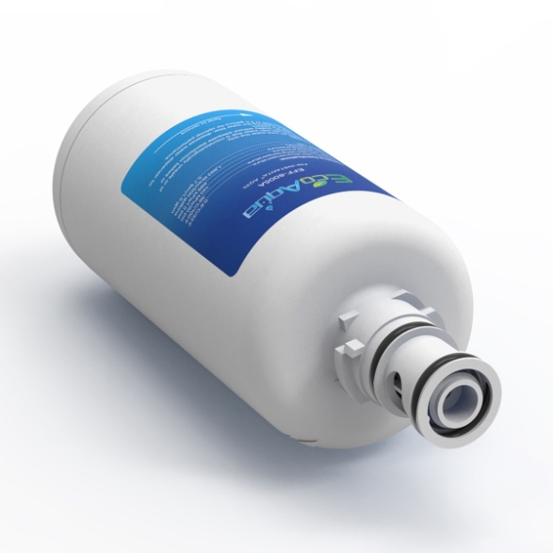

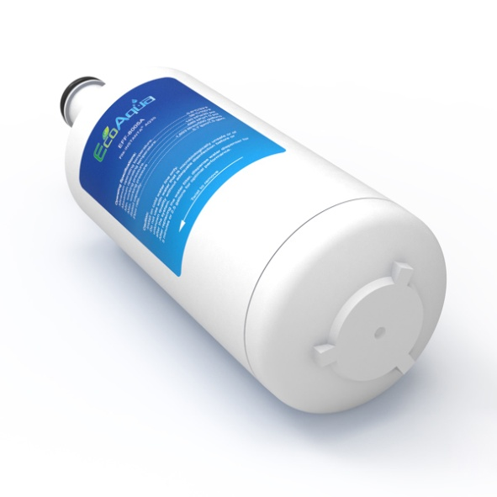

Distributed by:
Aqua Cure Ltd,
Aqua Cure House, Hall Street,
Southport, PR9 0SE.
Tel: 01704 516916
www.aquacure.co.uk
sales@aquacure.co.uk

