Chefmaster 4 Shelf Convection Oven
Instruction Manual

Models

HEC819

Thank you for purchasing your Chefmaster Convection Oven. To make full use of the product please read this manual carefully before using the product and keep it safe for future reference.

Safety Tips

- If you find any damage when the product is unpacked, contact your Chefmaster supplier within 24 hours of receipt of goods
- Always position on a flat stable surface and do not store products on top of it
- Repairs should always be carried out by a qualified technician
- DO NOT submerge this product in water.
- Do not use direct jets/ high pressure water/ jet-clean-spray to clean this product.
- Do not use this product outdoors or place it in environments where there is open fire such as gas stove or kerosene stove in use
- Always switch off or unplug the unit before cleaning
- Always close the door gently to avoid damaging glass
- Move by holding the product by the base
- Always plug into a grounded outlet. Do not use an adapter or an extension cord.
- If the power cord becomes damaged it must be replaced by a qualified technician
- This product is not designed to be used by persons with reduced physical or mental capabilities, lack of experience or knowledge, unless they are given suitable supervision, this includes children.

Pack Contents

- 1 x Chefmaster Convection Oven
- 4x Removable Aluminum Trays
- 1 x 1.5M“ BSP Water Supply Hose,3/4 inch
- 1 x Manual

Before Use

- Remove all packaging including all protective plastic, from your Chefmaster Convection Oven
- Position on a flat surface
- Wipe the product thoroughly with soft damp cloth only. The trays can be wiped or rinsed
- Plug your Chefmaster Convection Oven into the mains
- The machine will now be ready to turn on
- Operate the oven for approximately 30 minutes at the temperature 200°C to remove any odour which may be emitted. This is due to oil used during manufacture or from the oven insulation, but is not harmful
Control Panel
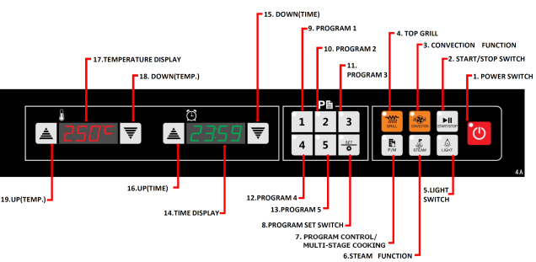
Program Set

- Ensure the Convection Oven is plugged in
- Press “Power” button to turn on
- The oven is in Program Mode (P) by default. Press “P/M” button to switch between Program Mode (P) and Multi-Stage Cooking Mode (M)

Programming for Program Mode (P)
- Ensure the oven is in “P” mode
- Press “Set” and then one of the program numbers “1-5”. The screens start to blink
- Select the desired temperature (5-260°C) with the “Up” / “Down” switches for temperature and time (Max. 99mins 59secs) with the “Up” / “Down” switches for timer
- Press “Set” to save the program
- Repeat the above steps to set the rest of programs if required

Programming for Multi-Stage Cooking Mode (M)
- Ensure the oven is in “M” mode
- Press “Set” and the number buttons “1-5” start to blink
- Press “1” & the button blinks. Select the desired temperature (5-260°C) with the “Up” / “Down” buttons for temperature and time (Max. 99mins 59secs) with the “Up” / “Down” buttons for timer
- When done, press “Set” to complete the set up for stage 1. It will turn into the setting for stage 2 automatically & the “2” button blinks
- 5 stages can be programmed in maximum. Repeat the above steps to set the rest of stages if required. If no program is required for the rest of stages, set time = 0 and press “Set” for each until stage 5 is set
- The program for Multi-Stage Cooking Mode (M) is now ready to use
Operation – Program Mode (P) / Multi-Stage Cooking Mode (M)

- Ensure the Convection Oven is plugged in
- Press “Power” button to turn on
- The oven is in “P” mode and “Convection” is selected by default. If no instruction is given, the oven will begin to keep warm at 65°C
- Press “P/M” button to switch from Program Mode to Multi-Stage Cooking Mode if required
- Press “Grill” button to switch from Convection to Grill if required
- Press one of the set programs “1-5”, then press “Start/Stop” to begin
- The oven will start to preheat & “pr-h” will be shown on screen
- When preheat is finished, the screen will show “food”. Open the door and place food on the trays directly or with food container, then close the door tightly
Note: the oven will stop to heat if the door is not closed tightly
- For Program Mode (P): The oven will start to cook as the time set for individual program selected
For Multi-Stage Cooking Mode (M): The oven will start to cook as the time set for all programs stored for Multi-Stage Cooking in sequence order e.g. if “2” is selected in M mode, the oven will process programs “2”,”3”,”4” and “5”
- When time is up, buzzer beeps and the screen shows “end”. The food is now ready for taken out. At the same time, the oven will begin to keep warm at 65°C

Caution: Be careful of hot air when the door is opened. Always use heat-resisted gloves to take out the food.

- Internal light can be switched on before or during the cooking process by pressing the “Light” button. It will turn off automatically in 30s
- Press “Steam” button during the cooking process for water spraying. It works only when the oven temperature is above 130°C

Note: There is a re-set button on the rear of the unit. The unit will stop working when temperature is too high. Press the re-set button to resume normal operation once the oven is cool down.

Connect water supply hose:

Water supply hose is required to be installed in order to use “Steam” function.

- Make sure the Oven is unplugged from main
- Rinse the hose with water to flush away dusts inside
- Connect hose to the water inlet on rear of the Oven, this will need to connected to 3/4 inch BSP main cold supply. Please note there may be a requirement for a water filter to be fitted (not supplied), deemed on the hardness of water supply, to avoid scale build-up.
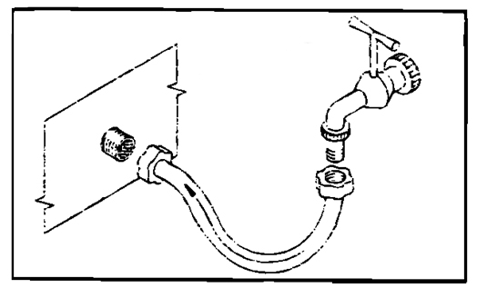
- Make sure both ends of hose are tightened, then open the water tap to allow water flowing into the Oven. “Steam” function is now ready for use

Noted: The temperature of water should be 0.5°F - 5°F to reduce sediment formation & pressure between 50kPa – 200kPa

Cleaning & Maintenance

- Before cleaning disconnect the oven from the power supply. Wash the shelves with warm soapy water and rinse with clean water
- All other parts of the oven can be cleaned with a damp cloth
- DO NOT submerge the oven in water or use water sprays to clean it
- Always clean your Chefmaster Convection Oven daily to avoid grease building up
- Use only non-abrasive cleaners and pads. Abrasive cleaners and scouring pads could scratch the finish of the oven

Troubleshooting

Condition | Possible Cause | Solution
The unit is plugged in but not working | 1. The unit is not switched on  2. The plug or lead are damaged  3. The fuse has blown  4. Overheat protection is triggered  5. The door is not closed properly | 1. Check the unit is correctly plugged in and switched on  2. Contact your Chefmaster distributor  3. Replace the fuse  4. Cool the unit for about 30 minutes, then press “reset” 5. Close the door tightly
The oven is not heating when the timer & temperature are both set & the screens are both on | 1. Digital controller may be broken  2. At least one of heating wires may have burnt out  3. Motor problem | Contact your Chefmaster distributor
The oven keeps heating in high temperature | The electronic board may be broken | Contact your Chefmaster distributor

Transportation and Storage

Please handle your oven with care to prevent any damage to the unit and internal parts. The product should be stored in a well ventilated area.

Do not store any flammable objects near the equipment.

Technical Information

HEC820 – Chefmaster 4 Shelf Convection Oven

Voltage ~230v 50Hz
Power 2.67Kw (Convection) / 2.15Kw (Grill)
Weight 41kg
Dimensions 595 x 595 x 570

- Chefmaster Convection Oven is supplied with a 3 pin plug and lead with a 13 amp fuse
- Appliance must be earthed
- If in doubt contact a qualified electrician or your Chefmaster distributor

Disposal

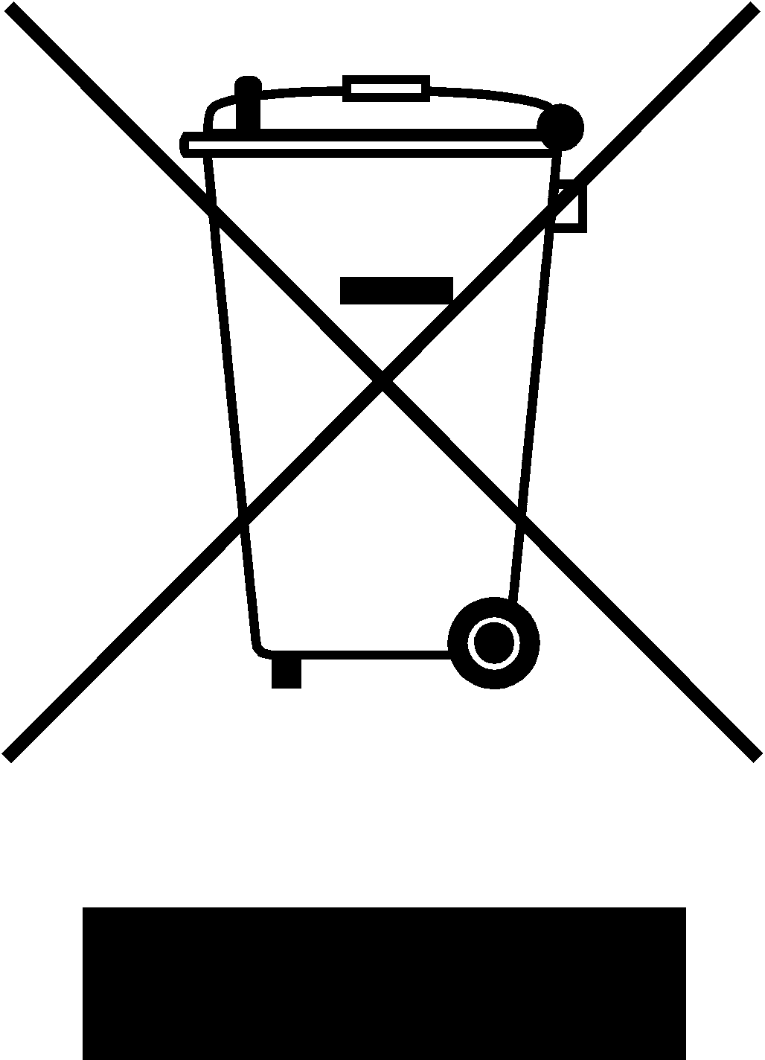

Under WEEE regulations this product must not be disposed of as household waste. To prevent damage to the environment and humans this product must be disposed of in an approved and environmentally friendly recycling process. For more information on how to dispose of this correctly please contact your Chefmaster distributor or local authority responsible for waste disposal.

Compliance

All Chefmaster parts and products have under gone a stringent testing process to ensure that comply with all European standards and specifications.
All Chefmaster products carry the CE approval symbol.

