

Chefmaster Juicer
Instruction Manual

Model
HEA892

Thank you for purchasing your Chefmaster Juicer. To make full use of the product please read this manual carefully before using the product and keep it safe for future reference.

Safety Tips

- If you find any damage when the product is unpacked, contact your Chefmaster supplier within 24 hours of receipt of goods
- Always position on a flat stable surface
- Repairs should always be carried out by a qualified technician
- Do not put your hand into the feed tube, only use the pusher supplied
- Keep hair & clothing clear of the unit when using it
- Do not use this product outside
- Always switch off and unplug the unit before cleaning
- Move by holding the product by the base
- Always store flat and do no store products on top of it
- If the power cord becomes damaged it must be replaced by a qualified technician
- This product is not designed to be used by persons with reduced physical or mental capabilities, lack of experience or knowledge, unless they are given suitable supervision, this includes children.

Pack Contents

1. Speed knob 2. Pulse button 3. Main body
4. Pulp container 5. Juice cup 6. Juice cup lid
7. Locking arm 8. Anti-drip spout 9. Juice collecting plate 10. Filter net 11. Juicer cover 12. Pusher

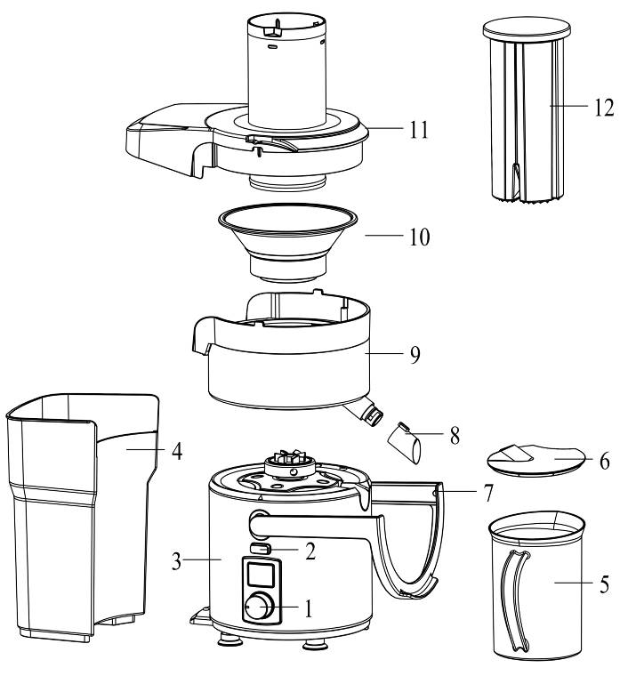

Installation

- Please remove all package and the paper on the filter net (10) before using your Chefmaster Juicer
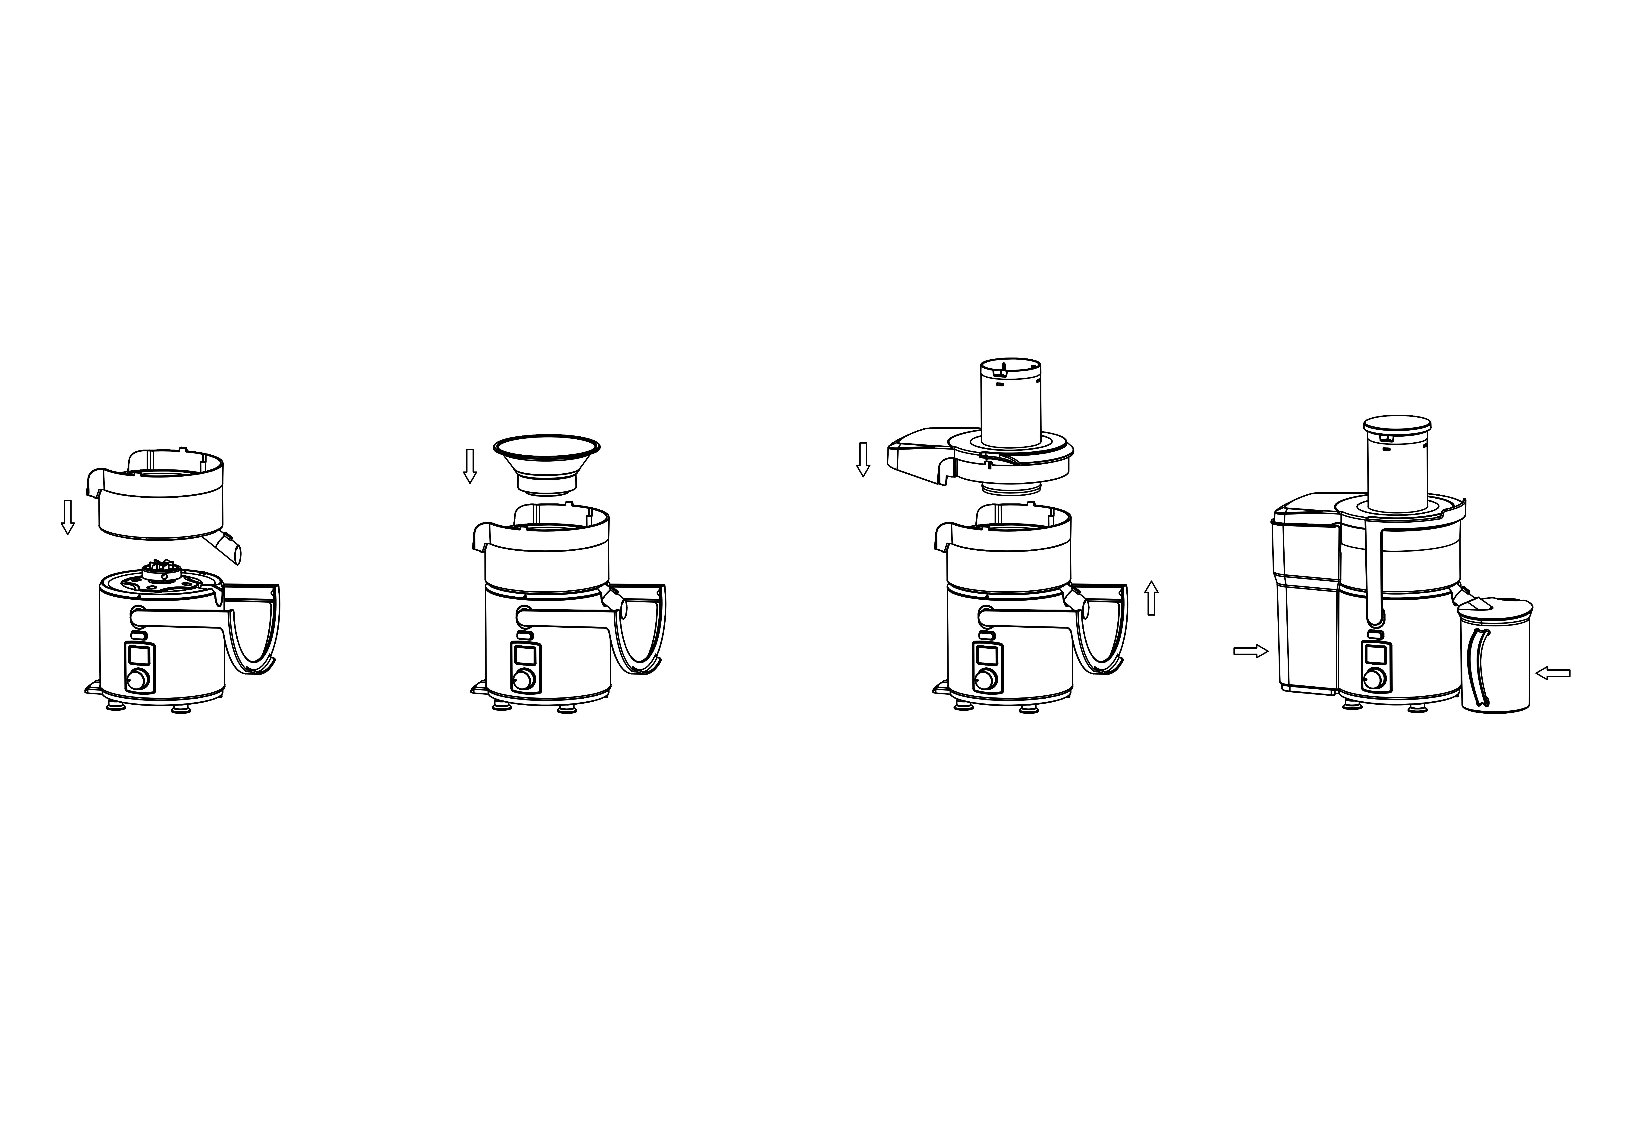

Position the Juice collecting plate (9) into the main body (3)

Put the filter net (10) on the base, so it connects with the gearing at the top of the main body (3)

Put the juicer cover (11) onto juice collecting plate and lock the locking arm (7). Make sure the safety pin is in right position

Put the pulp container (4) and the juice cup (6 & 7) in position, as shown in picture.

Plug and turn on the unit. The LCD will display the speed and function. Adjust the speed by turning the speed knob (1)

- If the motor stops during operation this will be because the juicer motor has got too hot. Switch it off and leave it to cool for 15 minutes. Once cooled, the juicer can be used again
- This juicer has safety switches, if it is not properly assembled it will not work

Cleaning & Maintenance

- Before cleaning disconnect the juicer from the electricity supply.
- Never immerse the main body in water or use a spray gun, wipe it with a damp soft cloth.
- Remove all other parts and rinse with hot water. During use, you may need to remove and empty the filter, if not juice may not flow.
- Always clean your Chefmaster Juicer daily

Troubleshooting

Fault | Possible Cause | Solution
The power indicator light is not on | The unit is not switched on  The plug or lead are damaged  The fuse has blown  Safety switch is triggered | Check the unit is plugged in and switched on  Contact your Chefmaster distributor  Replace the fuse  Unplug the unit. Check it is assembled properly and the locking arm is locked. Plug in and switch on again
The unit is on, but the motor is turning slowly or not at all | The motor is too hot. | Switch off and leave for 15 minutes. If the unit is still not working please contact your Chefmaster distributor

Transportation and Storage

Please handle your juicer with care to prevent any damage to the unit and internal parts. The juicer should be stored somewhere which is ventilation and non-corrosive gas.

Do not store any flammable objects near the equipment.

Technical Information

HEA892 – Chefmaster Juicer
Voltage ~230v 50/60Hz
Power 1000watt
Weight 10.5kg

- Chefmaster Juicer is supplied with a 3 pin plug and lead with a 13 amp fuse
- Appliance must be earthed
- If in doubt contact a qualified electrician or your Chefmaster distributor
Disposal

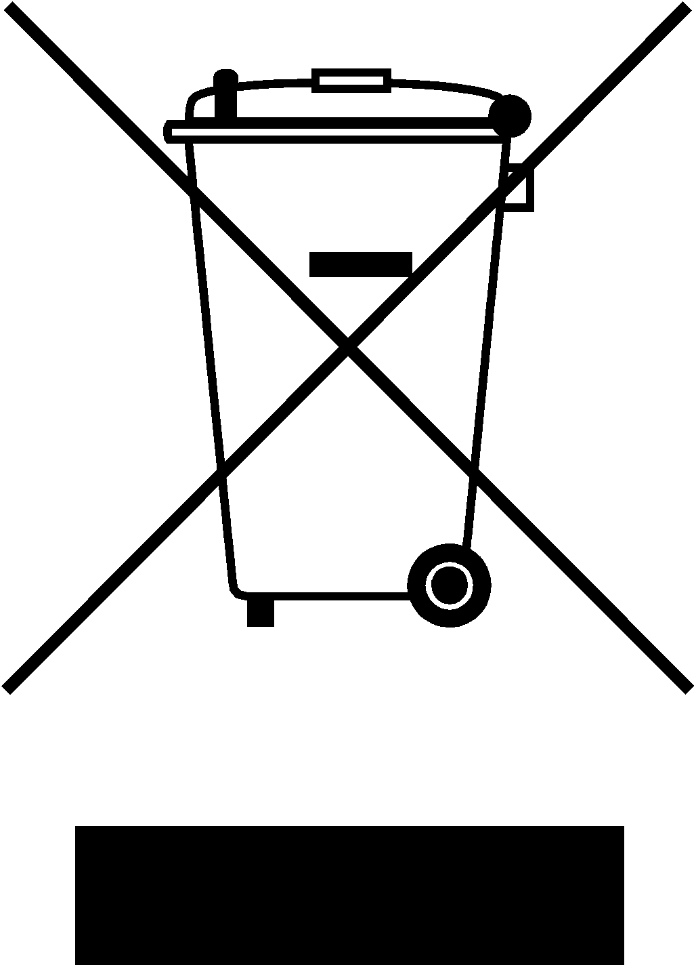

Under WEEE regulations this product must not be disposed of as household waste. To prevent damage to the environment and humans this product must be disposed of in an approved and environmentally friendly recycling process. For more information on how to dispose of this correctly please contact your Chefmaster distributor or local authority responsible for waste disposal.

Compliance


All Chefmaster parts and products have under gone a stringent testing process to ensure that comply with all European standards and specifications.
All Chefmaster products carry the CE approval symbol.

