

Chefmaster Automatic Juicer
Instruction Manual

Model
HEA873 – Automatic Juicer

Thank you for purchasing your Chefmaster Automatic Juicer. To make full use of the product please read this manual carefully before using the product and keep it safe for future reference.

Safety Tips

- If you find any damage when the product is unpacked, contact your Chefmaster supplier within 24 hours of receipt of goods
- Always position on a flat stable surface
- Repairs should always be carried out by a qualified technician
- Do not use this product if the cone is damaged
- Keep hair & clothing clear of the unit when using it
- Do not use this product outside
- Always switch off and unplug the unit before cleaning
- Move by holding the product by the base
- Do not remove the lid of the machine until the disc and basket have finished moving
- Always use the pusher provided, never try and insert your hand into the hopper
- Never use this product for frozen fruit or vegetables
- Always store flat and do no store products on top of it
- If the power cord becomes damaged it must be replaced by a qualified technician
- This product is not designed to be used by persons with reduced physical or mental capabilities, lack of experience or knowledge, unless they are given suitable supervision, this includes children.

Assembly

Before assembly ensure you wash all parts that will come into contact with food.

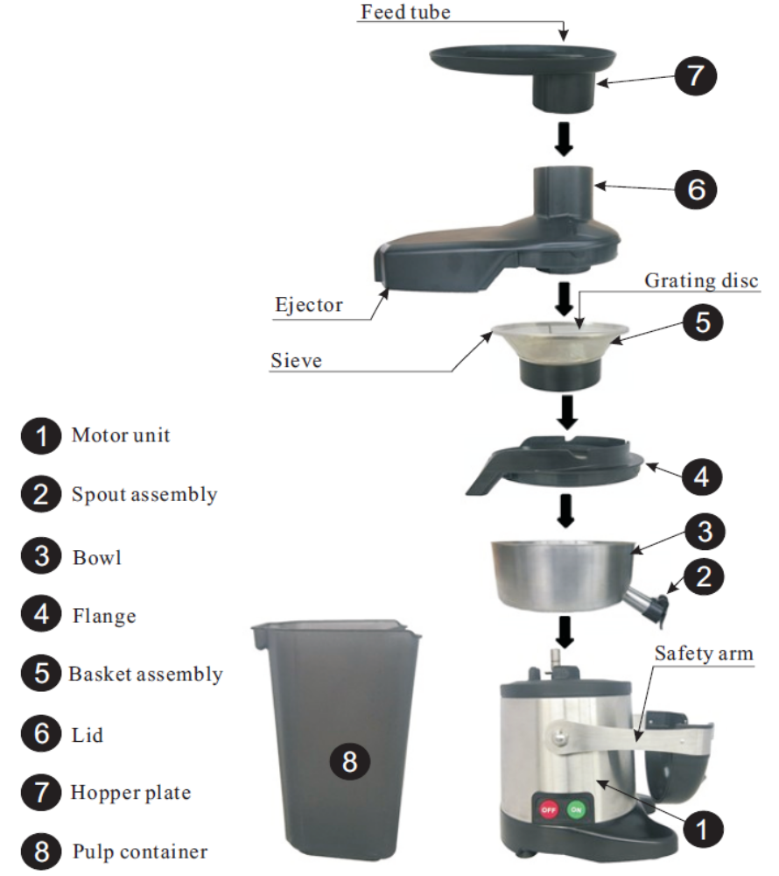

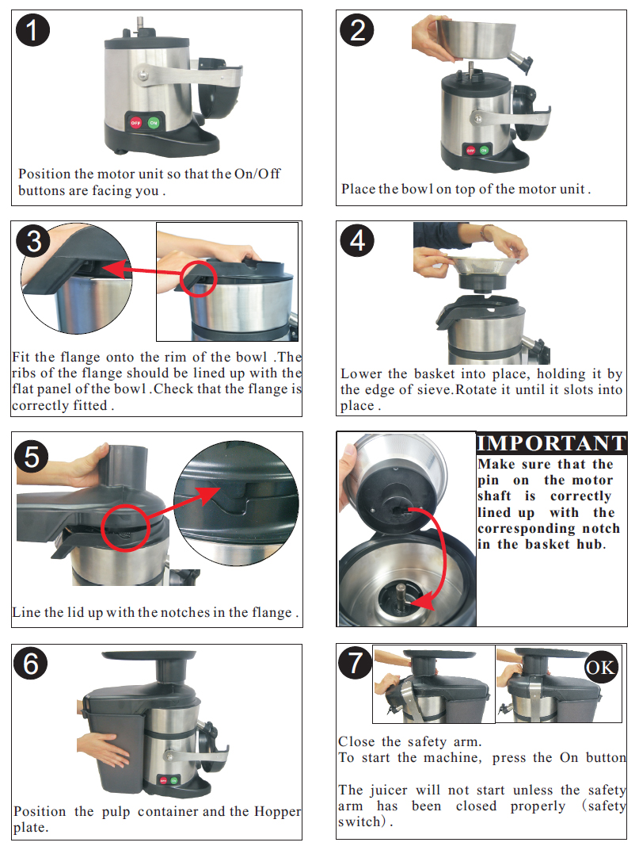

Before Use

- Remove all packaging including all protective plastic from your Chefmaster Automatic Juicer
- Position on a flat surface
- Plug your Chefmaster Automatic Juicer into the mains
- Ensure the safety arm is locked in place
- Ensure the pulp collector is in place
- Position a jug or glass below the spout
- The juicer will now be ready to use

Fruit and vegetable preparation

- Carrots – Peel, top and tail
- Apples – Whole as long as they fit within the hopper
- Strawberries – Remove stalks
- Citrus Fruit – Peel and can be left whole if they fit within the hopper
- Pineapples – Peel and cut into chunks
- Melons – Peel and cut into chunks
- Tomatoes – Wash and leave whole as long as they fit within the hopper
- Peppers – Wash and cut into strips so they fit in the hopper
- Cucumber – Peel and cut into chunks
- Ginger – Cut into chunks, no need to peel
- Grapes – Remove stalks to avoid a bitter taste
- Mangoes – Peel and remove the stone, then cut into chunks

This juicer is not suitable for very hard fruit & vegetables like Coconut
Always remove hard stones from fruit such as Peaches, Apricots & Cherries

How to use

- Ensure the locking arm is in place, if not the unit will not start
- Ensure the pulp container is in place at the rear and a jug is under the spout
- Push the on button
- Insert the fruit or vegetable into the hopper, use the pusher to slowly push it completely down the hopper
- Once you have finished juicing leave the machine to run for a few seconds to allow all the juice to be extracted

Cleaning & Maintenance

- Before cleaning disconnect the automatic juicer from the electricity supply.
- Never immerse the motor base in water or use a spray gun. Wipe the base with a damp soft cloth.
- Remove all other parts and rinse with hot water. During use, you may need to remove and empty the basket, if it has become blocked with pulp
- If juicing large quantities you may need to remove the pulp container
- Always clean your Chefmaster Automatic Juicer daily

Troubleshooting

Fault | Possible Cause | Solution
The power indicator light is not on | The unit is not switched on  The plug or lead are damaged  The fuse has blown | Check the unit is plugged in and switched on  Contact your Chefmaster distributor  Replace the fuse
The unit will not switch on | Safety switch | Ensure the unit is properly assembled and the locking arm is correctly positioned
The unit is vibrating during use | The basket maybe blocked | The basket can sometimes have more pulp unevenly distributed within it, clean the basket

Transportation and Storage

Please handle your automatic juicer with care to prevent any damage to the unit and internal parts. The automatic juicer should be stored somewhere which is ventilation and non-corrosive gas.

Do not store any flammable objects near the equipment.

Technical Information

HEA873 – Chefmaster Automatic Juicer
Voltage ~230v 50/60Hz
Power 700watt
Weight 13.3kg
Dimensions 257 x 473 x 522mm

- Chefmaster Automatic Juicer is supplied with a 3 pin plug and lead with a 13 amp fuse
- Appliance must be earthed
- If in doubt contact a qualified electrician or your Chefmaster distributor

Disposal

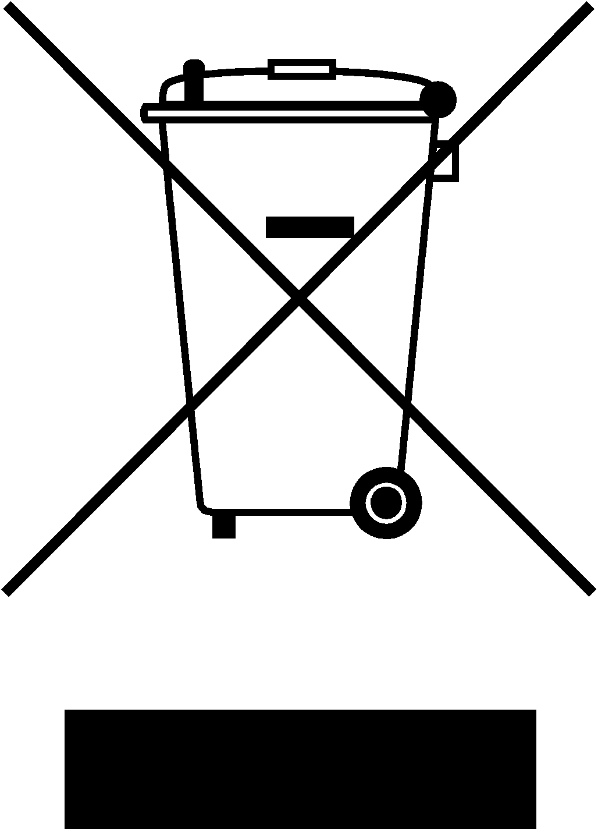

Under WEEE regulations this product must not be disposed of as household waste. To prevent damage to the environment and humans this product must be disposed of in an approved and environmentally friendly recycling process. For more information on how to dispose of this correctly please contact your Chefmaster distributor or local authority responsible for waste disposal.

Compliance


All Chefmaster parts and products have under gone a stringent testing process to ensure that comply with all European standards and specifications.
All Chefmaster products carry the CE approval symbol.

