**CHEFMASTER 250MM MEAT SLICER – HEA759**

Instruction to Release Blade Guard

1. Turn off the meat slicer (preferably unplugged)
2. Release the bigger bolt (the lower one) which can be found at the rear of the meat slicer

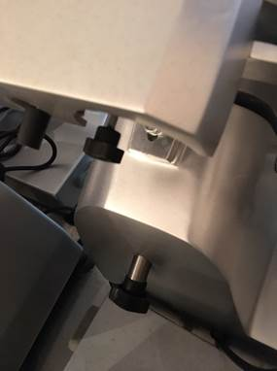

1. Push the bolt upwards once it is completely released. The blade guard is then ready to remove.